

**FUNDING REQUEST APPLICATION FORM**

**Full Review**

|  |  |  |  |
| --- | --- | --- | --- |
| **SUMMARY INFORMATION** | | | |
| **Applicant** | Bangladesh CCM | | |
| **Component(s)** | Tuberculosis | | |
| **Principal Recipient(s)** | External Resource Division (ERD), MoF& BRAC | | |
| **Envisioned grant(s) start date** | 1. January 2018 | **Envisioned grant(s) end date** | 31. December 2020 |
| **Allocation funding request** |  | **Prioritized above allocation request** |  |

|  |
| --- |
| ***IMPORTANT:***  **To complete this funding request**, please:   * Refer to the accompanying***Funding Request Instructions: Full Review****;* * Refer to the Information Note for each component as relevant to the funding request, and other guidance available, found on the [Global Fund website](http://www.theglobalfund.org/en/applying/funding/resources/). * Ensure that all mandatory attachments have been completed and attached. To assist with this, an application checklist is provided in the Annex of the*Instructions*; * Ensure consistency across documentation.   **Applicants are encouraged to submit a joint funding request** for eligible disease components and resilient and sustainable systems for health (RSSH).  **Joint TB/HIV submissions are compulsory for a selected number of countries with highest rates of co-infection.** See the related [guidance](http://www.theglobalfund.org/en/applying/funding/resources/#coreinformationnotes)for more information. |

**This funding request includes the following sections:**

**Section 1**: Context related to the funding request

**Section 2**: Program elements proposed for Global Fund support, including rationale

**Section 3**: Planned implementation arrangements and risk mitigation measures

**Section 4**: Funding landscape, co-financing and sustainability

**Section 5**: Prioritized above allocation request

|  |
| --- |
| **SECTION 1: CONTEXT** |
| This section shouldcapture in a concise way relevant information on the country context.Attach and refer to key contextual documentation justifying the choice of interventions proposed. To respond, refer to additional guidance provided in the*Instructions*. |

|  |  |  |  |  |
| --- | --- | --- | --- | --- |
| **1.1 Key reference documents on country context** | | | | |
| List contextual documentation for key areas in the table provided below. If key information for effective programming is not available, specify this in the table (“N/A”) and explain in Section 1.2how this was dealt with within the context of the request,including plans, if any, to address such gaps.  Applicant response in table below. | | | | |
| **Key area** | **Applicable reference document(s)** | **Relevant section(s)& pages nb.** | **N/A** |
| **Resilient and Sustainable Systems for Health (RSSH)** | | | |
| Health system overview | Health Bulletin 2015, Ministry of Health and Family Welfare, Government of the People’s Republic of Bangladesh |  | ☐ |
| Health system strategy | Health Bulletin 2015, Ministry of Health and Family Welfare, Government of the People’s Republic of Bangladesh |  | ☐ |
| Human rights and gender considerations (cross-cutting) | Document in preparation |  | ☐ |
| **Disease-specific** | | | |
| Epidemillionlogical profile (including interventions for key and vulnerable populations, as relevant) | National Strategic Plan for TB Control  2018-2022, National TB Control Programme, Government of the People's Republic of Bangladesh |  | ☐ |
| Disease strategy (including interventions for key and vulnerable populations, as relevant) | National Strategic Plan for TB Control  2018-2022, National TB Control Programme, Government of the People's Republic of Bangladesh |  | ☐ |
| Operational plan, including budgetary framework | National Strategic Plan for TB Control  2018-2022, National TB Control Programme, Government of the People's Republic of Bangladesh |  | ☐ |
| Program reviews and/or evaluations | Report on the Joint Review Mission of the National TB Programme 12 – 17 November 2016, National TB Control Programme, Government of the People's Republic of Bangladesh |  | ☐ |
| Human rights and gender considerations (disease-specific) | Document in preparation |  | ☐ |
| *Add rows as relevant, for any additional key area as relevant to the funding request* | | | |

|  |
| --- |
| **1.2 Summary of country context** |
| To complement the reference documents listed in Section 1.1 above, provide a summary of the critical elements within the context that informed the development of the funding request. The brief description of the context should cover disease-specific and RSSH components, as appropriate, as well as human rights and gender-related considerations.  **(maximum 2 pages per component)** |

The key background document for the funding proposal is the recently completed National Strategic Plan for TB Control 2018-2022, whose strategies were developed to address the findings and recommendations of the previously conducted Joint Review Mission(JRM) of the National TB Programme 2016. Both documents drew on the findings of the most recent TB prevalence survey conducted in 2015/2016. The JRM concluded that TB remains a major public health problem in Bangladesh. Current WHO estimates indicate that 43% of all cases are not being diagnosed, and the prevalence survey 2015/2016 showed that a large proportion of diagnosed cases is detected at advanced stages of the disease. However, the JRM also found that the NTP and its partners have maintained very good "basic TB control services" with reasonable case detection and excellent treatment outcomes during recent years. Government of Bangladesh (GOB), the Global Fund, USAID and other funding partners have increased or maintained their financial commitment to TB control during the past three years, enabling the NTP to continuously strengthen its activities and to address the challenges of TB/HIV, multidrug resistant (MDR) TB, intensified case finding in high risk groups and vulnerable populations and the use of new technologies. The following major achievements were noted by the JRM:

* **There has been a continuous increase in case notifications while maintaining high cure rates**

TB case notifications have increased significantly since 2012, mainly driven by increased numbers of extra-pulmonary and clinically diagnosed pulmonary cases. These results have been achieved through a good engagement of community workers for case finding activities, the provision of financial support for x-ray, FNAC, biopsy and other examinations, active/enhanced case finding in high-risk groups, and the expansion of Public Private Mix (PPM) activities.

* **The successfull implementation of integrated TB control activities in partnership with NGOs has continued**

Bangladesh represents a unique example of close collaboration between NTP and NGOs. A participatory approach in planning and budgeting is evident centrally, and there is close collaboration between the two Global Fund Principal Recipients, GOB and BRAC.

* **The use of new technologies for diagnosis is expanding**

The number of Gene Xpert sites has continuously increased during the past three years.

* 1. **Electronic recording/reporting systems are widely available**

Electronic recording/reporting systems are now available in all divisions.

* **MDR-TB case notifications are increasing while maintaining high cure rates for MDR-TB cases**

The number of detected MDR-TB cases has increased from 505 in 2012 to 880 in 2015. The treatment success rate of the last year cohort is 73% and 80% for 20-months regimen and 9-months regimen, respectively, exceeding international averages.

* **Good models to link diverse public and private health care providers and hospitals,professional bodies and associations, and NTP for the diagnosis and treatment of TB patients exist**

There is now widespread acceptance of private providers as one of the important target groups for outreach and referral of presumptive TB casesas well as direct diagnosis of TB patients, and private providers have become a major source of TB referrals in some areas.

Despite the substantial achievements, major obstacles towards effective control of the TB epidemic remain. The development of the funding proposal was informed by themain challenges noted by the JRM, including the following:

* **More than 40% of all TB cases are still not diagnosed**

Despite increases in case detection, current WHO estimates indicate that 43% of all cases are not being diagnosed. Undetected cases may experience morbidity and contribute to mortality and remain as sources of infection in the community and perpetuate the TB epidemic.

* **Successful active case finding activities at community level have not yet been expanded to cover the whole country**

The intensity of community-based case finding activities varies greatly between various divisions and districts in the country. These variations are mostly linked to different NGOs engaged in TB control in different areas, with some NGOs (e.g., BRAC) employing very effective case finding strategies, while activities of other NGOs are far more limited.

* **The engagement of individual private practitioners and public/private hospitals has remained limited, and mandatory TB case notification is yet to be operationalized**

Typically, only ~20% of graduate private providers in a certain area are actively referring. Not all hospitals have DOTS corners (50/102 academic medical institutes engaged; few of the 4,280 private hospitals). There is no mechanism to ensure mandatory TB case notification yet, although the first steps in designing such a mechanism have been taken.

* **Coordination of the TB response in urban areas is weak**

TB is more prevalent in urban than rural areas, but not all urban clinics have TB services and TB services have been removed from most Urban Primary Health Care Services Delivery Project (UPHCSDP) urban clinics. There is no engagement of private diagnostic labs, and in general private provider categories were mostly engaged “one by one” rather than in private sector referral networks.

* **Childhood TB detection and management largely insufficient**

The proportion of children among all cases was static between 2.6 to 3% in 2006 to 2013 and has risen to 4% during the past 2 years (2014-2015), driven by intensive networking with paediatricians and strengthening contact investigation activities throughout the country. This proportion is still substantially lower than the international average of around 10%, indicating that many child TB cases remain undiagnosed.

* **Coverage with new diagnostic technologies has remained incomplete**

Despite installation of Gene Xpert machines in most districts of the country, access remains difficult, as an effective sputum sample transport mechanism has not yet been implemented countrywide.

* **Electronic recording/reporting systems have not yet reached full coverage**

Electronic recording/reporting systems are not yet available county-wide, and only two of Bangladesh’s eight divisions have complete e-TB Manager coverage. Even though all divisions are sending e-TB Manager reports to the central level, NTP is currently not using the data for its aggregated reports.DHIS-2 is currently being used for data collection of aggregate data.

|  |
| --- |
| **1.3 Past implementation and lessons-learned from Global Fund and other donor investments** |
| 1. List recent disease-specific Global Fund grants from the 2014-16 allocation period and summarize key lessons learned from their implementation. 2. Include lessons-learned from specific HSS grants or any HSS investments embedded in the disease-specific grant(s) from the 2014-16 allocation period as applicable. 3. Outline lessons learned from investments by other donors as applicable.   For each of the above, explain how these lessons learned are taken into account in this funding request.  **(maximum 1 page per component)** |

The current Global Fund grant under the New Funding Model (NFM) covered the period July 2015 until December 2017. The TB component of the NFM grant received a substantial amount of above-allocation funding, addressing the strong concern about the prospect of declining program performance under a potentially insufficient allocation funding amount expressed in the grant application. Similar to the Global Fund, GOB, USAID and other funding partners have increased or maintained their financial commitment to TB control during the past three years. A prevalence survey was conducted during the NFM grant application period, and its findings have major implications for the lessons learned during the past three years. Of major importance for the development of the current funding proposal are the following lessons learnt:

* **The NTP was able to directly translate a funding increase into a substantially increased case detection level**

The key concern about the TB situation in Bangladesh during recent years has been a relatively low case detection level, despite adequate program performance in terms of treatment success for detected cases. The increase of case detection was the key issue highlighted in the NFM grant proposal. The experience during NFM grant implementation has shown that the NTP is able to directly translate an increase of funding into increased case detection rates. During the grant implementation period, the case detection rate for all forms of TB increased from 125/100,000 in 2013 to 135.1/100,000 in 2015.

* **Community-based case finding activities can be very effective in increasing case detection levels**

Currently, the intensity of community-based case finding activities varies greatly between various divisions and districts in the country. An important observation during the JRM was that case detection levels have significantly higher in areas with a high intensity of community-based case finding activities, highlighting the importance of this intervention for further increased case finding throughout the country

* **PPM activities have been successful in increasing case detection**

As a result of intensified PPM activities during recent years, there is now widespread acceptance of private providers as one of the important target groups for outreach and referral of presumptives. This is seen in urban clinics that integrated TB services (with high yield and at low cost) and in other delivery models that combined direct referral by community-based volunteers with outreach efforts to private providers. The effect of these interventions has been a continuous increase of the proportion of TB referrals from the private sector to NTP case finding, reaching 29% in 2016.

* **Improved access to chest X-ray has been critical for increasing case detection of smear-negative cases**

An increase of clinically diagnosed pulmonary cases (without bacteriological confirmation) contributed significantly to the recent rise of case detection levels. Financial support for poor presumptive cases with negative smear results to obtain x-ray examinations has been provided under the NFM grant, and it is likely that this initiative is at least partially responsible for the increase in smear-negative notifications.

* **The higher sensitivity of Gene Xpert compared to smear-microscopy has the potential to significantly increase case detection levels**

During the recently conducted prevalence survey, all presumptive cases were evaluated with both smear microscopy and Gene Xpert. The results of the survey showed a consistently higher sensitivity of Gene Xpert across all patient groups, highlighting the potential role of the test to further increase case detection

* **Existing Gene Xpert machines have remained underutilized due to a restrictive diagnostic algorithms and lack of access from peripheral levels**

The current standard NTP diagnostic algorithm still specifies smear microscopy as the primary diagnostic tool, and requires Gene Xpert examination only for confirmed cases with a high risk of MDR-TB. Also, access to existing machines has remained difficult from remote areas where a sputum sample transport mechanism has not yet been effectively implemented. As a result, the JRM noted that nearly all existing Gene Xpert machines have been under-utilized. An additional factor leading to under-utilization was the lack of regular maintenance of Xpert machines, which resulted in some machines being out of order for prolonged periods of time.

* **More than 50% of prevalent cases do not meet the current presumptive criteria that would be detected by current diagnostic algorithms**

A key finding of the recent prevalence survey was that more than 50% of prevalent cases do not have any symptoms listed in current diagnostic algorithms, i.e., they were only detected due to the mass X-ray screening used during the prevalence survey. In addition, more than 30% of prevalent cases do not seek for any care.These findings have major implications for the future role of active case finding and screening activities.

* **The prevalence survey highlighted gender-specific and geographic risk factors for TB**

The prevalence survey showed a consistently higher prevalence of TB among males of all age groups, elderly as well as a higher prevalence of the disease in urban areas, highlighting the need for specific interventions addressing these risk factors.

* **The prevalence of MDR-TB may be lower than previously assumed**

The NTP had previously estimated a total number of 9,700 MDR-TB cases that could be detected through intensified MDR-TB detection activities. That figure was derived be extrapolating the results of the 2011 DRS, which showed 1.6% and 29% MDR in new- and retreatment cases, respectively. During NFM implementation, the NTP has received results from pilot projects in multiple areas in which all cases were tested with Gene Xpert.The empirically observed figures are significantly different from those that could be expected on the basis of the DRS results. On average, the actually observed MDR level is 0.21% in new cases, and 2.9% in retreatment cases. The NTP will conduct another DRS in 2017, and the results of that study will be used to update the projected number of MDR-TB cases.

|  |
| --- |
| **SECTION 2: FUNDING REQUEST (Within Allocation)** |
| This section should describeand provide a rationale for the program elements proposed for this funding request.Attach and refer to completed**Programmatic Gap Table(s), Funding Landscape Table(s), Performance Framework and Budget**, and refer to national strategy documents as applicable.  To respond, refer toadditionalguidance provided in the*Instructions.*  Ensure that the funding request as described in questions 2.1 and/or 2.2 meets the focus of application requirement as outlined in section 2.3. |

|  |
| --- |
| **2.1 Disease-specific funding request**  *Not applicable if the application is a standaloneRSSH request.* |
| Given the context and lessons learned outlined in Section 1,   1. Describe the disease-specific funding request(s), the rationale for prioritizing modules and interventions, and how these choices ensure the highest possible impact with a view to ending the three diseases and removing human rights and gender-related barriers to accessing services.   For any priority modules for which gaps are difficult to quantify in the programmatic gap tables, explain here the barriers being addressed, the proposed interventions and the population or groups involved.   1. Explain how the funding request addresses the key funding gaps reflected in the Funding Landscape Table(s) for the disease program(s) in the current allocation cycle, and specify other actions planned to cover remaining gaps.   For funding requests including both HIV and TB components:   1. Describe the coordination of joint TB and HIV strategies, policies and interventions at different levels of the health system, including community systems, and expected impact and efficiencies from the joint programming.   Ensure the answer appropriately reflects the separate disease programs in addition to cross cutting modules where appropriate.  **(maximum 4pages per component)** |

The funding request was prepared on the basis of the recently developed National Strategic Plan for TB Control (NSP). The NSP, in turn, was developed in line with WHO’s End TB Strategy. Building on the Strategy’s Three Pillars (I. INTEGRATED, PATIENT-CENTRED CARE AND PREVENTION; II. BOLD POLICIES AND SUPPORTIVE SYSTEMS; III. INTENSIFIED RESEARCH AND INNOVATION) and following the key principles of government stewardship and accountability, strong coalition with civil society organizations and communities, protection and promotion of human rights, ethics and equity, and adaptation of the strategy and targets at country level, the NSP 2018-2022 describes key interventions and activities that will enable the NTP to achieve the End TB Strategy’s Milestones for 2025 (75% reduction in tuberculosis deaths and 50% reduction in tuberculosis incidence rate) and targets for 2035 (95% reduction in tuberculosis deaths and 90% reduction in tuberculosis incidence rate).The NSP also accounts for the 90-90-90 targets of the Global plan of the Stop TB Partnership. Of key importance for the development of the NSP as well as the preparation of the funding proposal was an assessment of the potential impact of alternative interventions, using the recently developed TB Impact Model and Estimates (TIME)[1]. In high-level summary, the model has parameters related to the natural history of TB, including processes such as the epidemillionlogical contact rate between active infected and susceptible cases, primary infection, reactivation of latent disease, conversion from SS- to SS+, parameters capturing the HIV-TB, MDR-TB and pediatric TB, to name but a few of the key elements of the model.The model also has structures for representing key aspects of TB programs, including the screening rate for SS+ cases, the relative screening rate of SS- cases and also TB susceptible cases compared to SS+ cases. The model further has structures for linking diagnosed cases to care, to DST and for the treatment success of cases initiated on treatment.

The modeling results showed that in order to achieve the End TB Strategy’s target of a 50% incidence reduction by 2025, it will be **crucial to increase the case detection ratio (CDR) to more than 90% by 2020.** Detailed modeling results are shown in the table and graph below.

Table1: TIME modeling results of NSP requirements to achieve End TB Strategy targets



Figure 2: Expected development of incidence under continuation of current intervention levels (baseline) and intensified interventions as specified in the NSP

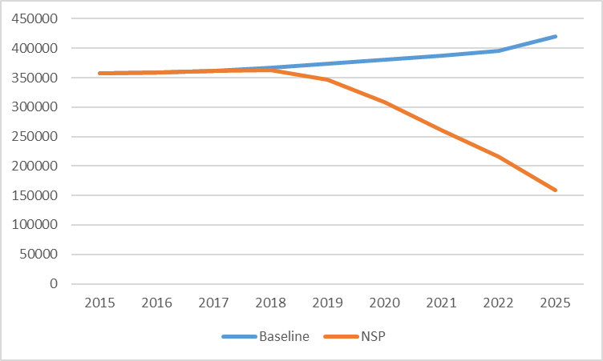

The development of the NSP and consecutively the allocation funding proposal was guided by the principle of investing available resources in those interventions that will achieve maximum impact. Based on internationally accepted principles as formulated in WHO's TB policy documents, maximum impact for TB control is expected from interventions that either increase case detection (for both drug-sensitive and MDR-TB cases) or improve treatment outcomes for detected cases. Over the previous years, the NTP has been very successful in establishing treatment services that assure very high treatment success rates for detected cases, regularly exceeding 90% for smear-positive cases. The further improvement of treatment outcomes was therefore not of primary concern for the development of the funding proposal. The total NSP funding requirements to achieve the target of >90% CDR by 2020 are USD 240million over the three-year period covered under the current funding proposal (2018-2020). The GOB funding contribution is expected to be USD 57 Million, and USAID support is expected to be around USD 24 Million.As a result of the prioritization of increasing case detection, NSP activities linked to the module “TB Care and Prevention: Case Detection and Diagnosis” requirea funding amount that significantly exceeds all other components of the NSP. As shown in the graph below, a significant funding gap remains for this module after expected contributions by the MOH and USAID are taken into account. The funding gap for the module “TB Care and Prevention: Treatment” is insignificant, due to the MOH’s commitment to finance the required supply of first line drugs in full, while the funding gaps for other modules are comparatively small.

Figure 3: NSP funding requirements and funding gaps by module

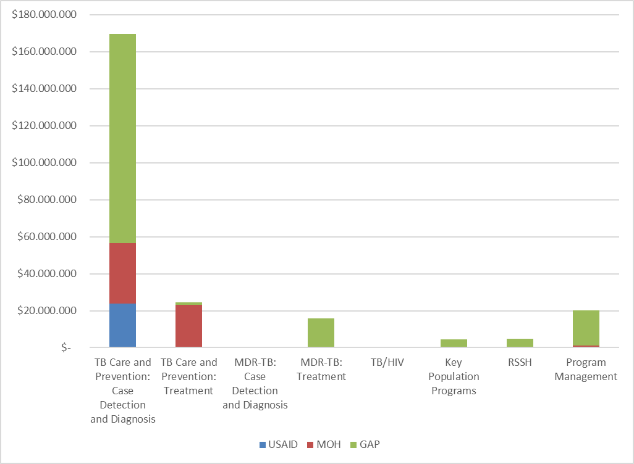

The proposed use of the allocation funding amount (USD 97.8 Million) focuses on the module with the largest funding gap (“TB Care and Prevention: Case Detection and Diagnosis”), while also considering the funding of key program components in other modules that will be required for effective implementation of case finding activities. The proposed distribution of the allocation funding amount by module is summarized in the figure below. 63% of the allocation funding amount is proposed to be invested in the module “TB Care and Prevention: Case Detection and Diagnosis”.

Figure 4: Proposed distribution of allocation funding amount by module

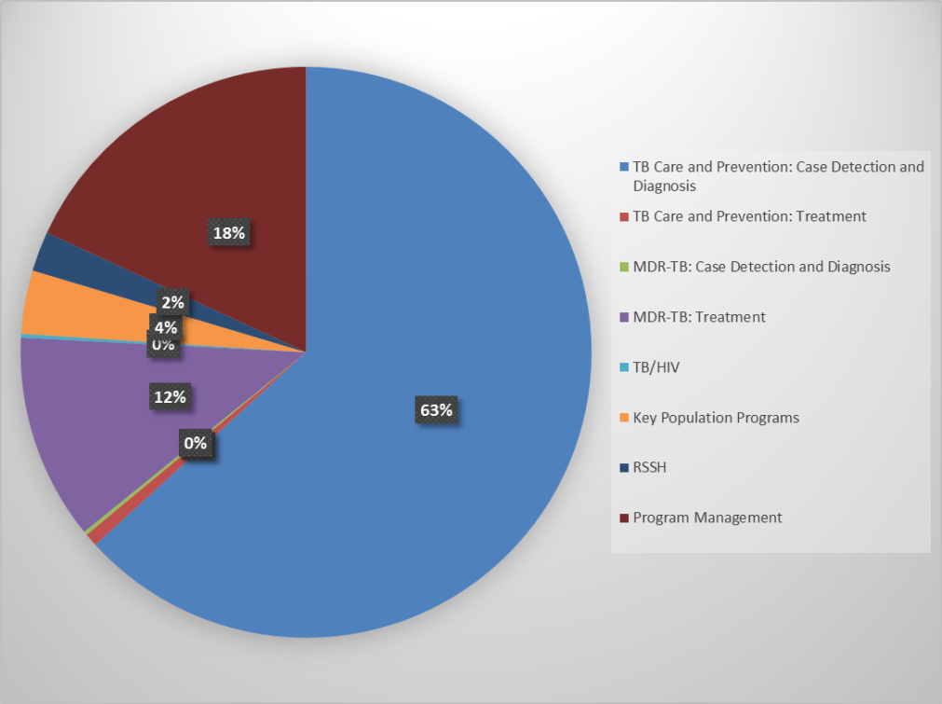

After accounting for the Allocation funding amount of USD 97.8 Million, a funding gap of USD 61.1Million or 25% of the total NSP funding requirements remains. This implies that**it will not be possible to achieve the full NSP targets under the allocation amount.**As shown in the figure below, the remaining funding gaps vary by module, with the funding gap for the key module “TB Care and Prevention: Case Detection and Diagnosis” remaining at 30%.The main activities for which a finding gap will remain concern the further expansion of community case finding activities, the introduction of the new diagnostic algorithm in additional upazillas, the provision of additional Xpert machines to cover all upazillas, and PPM activities targeting additional providers.

Figure 5: Remaining funding gaps by module after accounting for proposed use of allocation funding amount

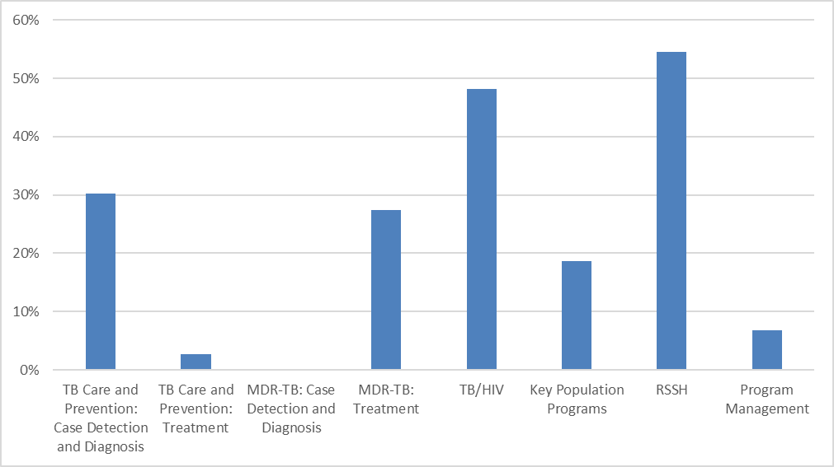

*Note: The funding gap for the module "TB care and prevention: Treatment" concerns costs associated with DOT provision and nutrition support – the costs of FLD provision are fully covered by GOB.* Based on the rationale outlined above, the focus for the investments proposed under the funding proposal was on interventions that will increase case detection levels. Accounting for the recommendations from the recently conducted JRM and the lessons learned described above, the following interventions were included in the allocation funding request:

* **Introduction of a new diagnostic algorithm**

Following the advent of new diagnostic technologies such as Gene Xpert (nucleic acidamplification for rapid and simultaneous detection of tuberculosis and rifampicin resistance), WHO has been actively promoting the use of revised screening algorithms to increase TB case detection[2]. More recently, WHO also confirmed the routine use of chest x-ray for screening and diagnosis as a means for increasing case detection[3]. Following these recommendations, the NTP has recently assessed the efficacy and cost implications of various diagnostic algorithms[4]. An NTP expert committee agreed that the use of the following diagnostic algorithm would provide most benefits in terms of increasing case detection with favourable cost implications:

*Revised NTP diagnostic algorithm[5]*



The NTP plans to initiate this algorithm from the beginning of 2017 and expect to cover 161 sites during the year 2017. During the implementation period of the new GF grant 2018-2020, the NTP will **introduce the new diagnostic algorithm at the 161 existing Xpert sites that currently exist or are expected during 2017 under the allocation funding request. These 161 machines will cover all districts, but will not provide decentralized access at the upazilla (sub-district) level.**

For **sites that do not have GeneXpert and X-rays during the phased implementation of the new algorithm**, the current diagnostic algorithm based on smear-microscopy will be continued. The use of smear microscopy for follow up investigations once patients are diagnosed will be continued in all upazillas (sub-districts).

* **Expansion of successful case-finding activities at community level**

The intensity of community-based case finding activities currently varies greatly between various divisions and districts in the country. These variations are mostly linked to different NGOs engaged in TB control in different areas, with some NGOs (e.g., BRAC) employing very effective case finding strategies, while activities of other NGOs are much more limited. The BRAC model currently covers 298 sub-districts (upazillas) of 42 districts with a population of 93 million.Under this strategy, successful models of community-based case finding activities will be expanded to all divisions and districts in the country. The NTP, in collaboration with NGO partners, will develop standard models describing logistics and staffing requirements based on the diversity of the types of client, providers and facilities.

* **Design and implementation of activities to increase case finding among specific high-risk areas or population groups**
  1. ***Urban areas***

This strategy will target high-risk geographic areas and populations and focus on strengthening urban TB program system components that include monitoring and supervision; financing; electronic notification, recording, and reporting; referral and follow-up; rational use of medicines; and private sector and community engagement. The urban approach will emphasize effective screening and passive and active case finding among migrant and floating populations and slum populations, people living with or at high risk of developing HIV, malnourished people, and children at risk in urban settings; attention will also be given to urban-based contact tracing and isoniazid preventive therapy interventions. The target under allocation funding will be the Dhaka metropolitan area.

* 1. ***Male population***

The recent prevalence survey consistently showed a higher prevalence of TB among the male population in all age groups. This strategy will address this specific epidemillionlogical situation through the development of policies to provide easier access to care for the male population, such as the establishment of clinics providing services outside of regular working hours(flexi hours).The target under allocation funding will be the Dhaka metropolitan area.

* **Establishment of additional diagnostic laboratory facilities to achieve a population coverage of 1/ 150,000**

Lack of access to diagnostic services is considered to be a key factor for low case detection in some geographic areas. WHO has defined an international standard target of one laboratory per 150,000 population. This target is currently not reached in many geographical areas in Bangladesh, with coverage being one per 200,000 in some areas. The establishment of new diagnostic facilities will have to take the specific geographic and demographic situations in individual areas into account. A key requirement will be the performance of comprehensive country mapping to determine the most feasible locations for additional laboratories. Under the allocation amount, an additional 842 microscopy facilities will be equipped with LED microscopes.

* **Strengthen the engagement of private providers in TB control activities**

The aim of public-private mix (PPM), or the involvement of all care providers, is to ensure an efficient link to quality-assured TB diagnosis and treatment. The first step is to identify all individuals with TB symptoms, wherever they are located in the health system, and to link them to public or private providers or sites with quality-assured TB diagnosis.

This is particularly important in Bangladesh, where 84% of presumptive TB cases who sought care in an urban setting went first to the private sector, whereas only 16% went directly to a DOTS facility. A substantial proportion of the missed TB cases in 2015 (43% of all estimated cases) are believed to be diagnosed and/or treated by the private sector. There are roughly 65,000 registered physicians in Bangladesh, 53% (approx.) of whom operate exclusively in the private sector.

This strategy will strengthen the engagement of private providers based on the activities described in the recently completed National Strategic Plan for Public-Private Mix[6]. The NTP and its partners will focus their efforts on expanding the engagement of qualified private physicians (including chest specialists), village doctors, drug sellers and pharmacy staff and public medical college hospitals in TB control. Several PPM models have been prioritized to achieve this aim. The table below presents the providers and expectations for expansion by 2020.

***PPM Provider Targets 2018-2020***

|  |  |  |  |  |
| --- | --- | --- | --- | --- |
| **Private Providers** | **Total** | **Currently**  **“Engaged”** | **Expansion Target** | **Target %** |
| Medical College Hospitals! | 102 | 38 | 80 | 78% |
| Graduate Medical Practitioners | 60,761 | 29,795!! | 49,954* | 82% |
| Relevant Professional Associations | 12 | 2 | 12 | 100% |
| Informal Healthcare Providers** | 340,000 | 4,000! | 40,000 | 12% |
| Workplaces | 6,334# | 688 | 1156^ | 18% |

The following approaches to PPM expansion will be used:

***Hospital Model***

BRAC and DF, in collaboration with NTP, have been implementing the medical college hospital model for TB care in 38 out of approximately 102 medical college hospitals in Bangladesh by establishing hospital TB corners that identify presumptive cases and refer them to different departments within the hospital for further evaluation. Once a patient is diagnosed with TB, he/she is referred back to the DOTS corner to start treatment. Treatment is initiated at the DOTS corner and patients whose residence is far from the hospitals, which are the vast majority, are referred to their closest DOTS facility where they are registered and continue treatment. Cases are formally transferred to minimize the potential for double counting. The model has been successful and has already been expanded to seven additional high-volume general hospitals as well. The NTP will scale-up the hospital model from 38 to 80 medical college hospitals. For training, providers will be selected based on the services they provide and their clients, with a focus on chest specialists; BRAC and NTP will provide training on TB and the referral mechanism and linkages between each department and the DOTS corners. Providers will be trained on ISTC and TB clinical topics such as MDR-TB treatment, paediatric and extra pulmonary TB. DOTS corner staff and laboratory staff will also be trained using standardized training materials. Monitoring and supervision will be conducted on a regular basis.

***Social Enterprise Model***

The social enterprise pilot model was introduced in 2014 in the Dhaka metropolitan area with the aim to strengthen the private sector in the management and care of TB by offering state of the art diagnostics, physician follow-up and support, and patient referral to DOTS centres. The model is led by icddr,b and since its introduction has involved 1,800 private providers, established three TB screening centres (SCs), and created strong linkages with public DOTS facilities, especially for the referrals of smear negative presumptive TB. In collaboration with icddr,b, the NTP plans to strengthen the model implementation in Dhaka and further expand the model to five more cities (Chittagong Metro, Khulna Metro, Rajshahi Metro, Sylhet Metro, and Barisal Metro). Ten additional screening centres, two in each city, will be established, equipped with digital chest x-ray, GeneXpert, and tools for screening for co-morbid conditions related to TB such as diabetes. Providers will be mapped and selected based on high patient volume and willingness to participate in PPM and field staff will be recruited and trained. During this expansion phase, icddr,b will also coordinate with NTP to introduce a private sector DOTS program in the SCs which will ensure quality-assured anti-TB drugs from NTP for patients who prefer taking treatment in the private sector.

***Urban Private Provider Pilot***

This pilot model aims to engage physicians operating in individual clinics, diagnostic centres and small private hospitals as well as drug sellers and pharmacy staff in TB detection and notification. It will be led by BRAC and will be implemented in specific geographic areas in Dhaka, urban and suburban, and in Gazipur, Narayanganj and Chittagong City Corporations. Providers will be selected based on the high patient volume; patients in these areas are often seeking healthcare from private providers and are not always reported under NTP. Seventy GPPs and seventy 70 drug sellers and pharmacy staff will be selected in each geographical area, providing a total 350 private practitioners and 350 drug sellers/ pharmacy staff to identify 700 TB cases annually. Graduate medical practitioners will be trained on the symptoms of TB, ISTC and other TB related areas and referral linkages between the providers and DOTS centres will be strengthened. Pharmacy staff and drug sellers will be trained on recognition of presumptive patients and use a referral system. This model emphasizes referral from private providers to NTP diagnostic facilities. Field staff will be recruited and will be responsible for coordination, networking and referral follow-up. A referral system, using SMS, will be used by the providers in the network to alert DOTS centres and project field staff when a presumptive referral is initiated. Quarterly performance review meetings will be conducted to review outcomes and performance and address bottlenecks during the implementation. In urban areas, drug sellers will receive a reimbursement for mobile phone referrals (US$ 2.50) from BRAC, and in rural areas village doctors receive the same amount from DF.

***Informal Healthcare Provider Model***

The informal healthcare provider model aims to engage village doctors, drug sellers and pharmacy owners and staff. These providers are situated in urban and rural communities and are often the first point of care. During the scale-up period, 10,000 village doctors, drug sellers and pharmacy owners and staff will be engaged annually in TB referral and /or provision of DOT, a total of 40,000 until 2020. This is a substantial increase over the 4,000 VDs currently engaged in PPM. To begin with, a rapid assessment will be conducted by the implementing partners to determine the types and numbers of providers in the selected areas. Selected village doctors, drug sellers and pharmacy owners and staff will be provided with training and regular distribution of TB supplies (anti-TB drugs and sputum cups) will ensure smooth and uninterrupted treatment. Project-based outreach workers will supervise the village doctors, drug sellers or pharmacy owners and staff and quarterly meetings will be organized to review performance, identify challenges and develop action plans. One outreach worker will be responsible for the supervision of 75 providers. Standardized referral slips will be introduced which will enable to trace referrals initiated by the providers and feedback systems using mHealth will be piloted. Appropriate performance appreciation schemes will also be introduced with the aim to keep providers motivated and engaged. It is anticipated that 7,000 TB cases per year will be detected through this model.

***Workplace Model***

The workplace TB care model aims to improve the environment for TB control in workplace settings. It does this principally through the introduction of outreach, TB diagnostics and DOTS into workplace health services. The model is diverse, encompassing three approaches. The first of these approaches is based on the BGMEA workplace service delivery model. Since 2010, BGMEA has established 11 health centres which provide TB diagnosis, treatment services and anti-TB drugs and education to 700,000 garment factory workers. It has also introduced the 14-day sick leave with pay for workers who are diagnosed with TB. BGMEA will scale up the model to an additional 114 garment factories, from 686 to 800, covering an additional 100,000 workers. They will establish 2 additional DOTS centres, bringing the total from 11 to 13, and strengthen existing TB services. BGMEA plans to conduct an interim evaluation that will inform the scale-up of the workplace model to other garment factories by 2020.

* **Increase detection of TB in children through promotion of the Roadmap for Childhood TB**

At around 4%, the proportion of childhood TB cases among all cases in Bangladesh is well below international averages. Under this strategy, the NTP will seek to increase the detection of childhood TB cases to a level of 8% of all detected TB cases by 2022. Components of the strategy will be a re-activation of the national Child TB Working Group and the improvement of political commitment through the engagement of opinion leaders at community level; the expansion of child TB training to all health care providers; the expansion of child TB training to all health care providers in remaining 5 (five) divisions and refreshers training in Dhaka and Sylhet divisions; the training of TLCA to undertake contact investigation for child TB, including Mantoux testing; provision of IPT for child contacts of active cases; support for other diagnostic tools, such chest radiography and gastric lavage for small children, along with appropriate training; and active case finding (ACF) of child TB through the investigation of contacts of SS+ adult cases. Ensure quality of contact tracing through monitoring and evaluation by UHFPO and Civil Surgeons. As child TB has subtle signs and symptoms a separate awareness and communication strategy will be formulated to empower the community.

* **Ensure the implementation of contact screening procedures at all facilities**

The screening of contacts of active TB cases for symptoms of TB is an important tool to increase case detection. While the new NTP Manual contains detailed instructions on the implementation of this method, the policies are rarely effectively implemented. This strategy will focus on the development of clear-cut operational guidelines and plans for implementation & monitoring, followed by training of all staff in contact investigation techniques, as well as the strengthening of supervision for this program component. In addition, local NGOs/CBOs will be mobilized through small implementation schemes.The target will be to ensure contact tracing for 100% of detected cases. The strategy also includes an assessment of Post Exposure Treatment for both DSTB and DRTB in a pilot project.

* **Ensure full implementation of WHO’s TB-HIV policy**

Under this strategy, the full package of WHO’s TB-HIV strategy will be implemented, including stronger TB/HIV collaboration between the NTP and NASP with coordinated guideline writing and biannual TB/HIV collaborative meetings; HIV screening for all newly-diagnosed TB cases; introduction of “provider initiated HIV testing” for DOTS clinics, hospitals, and areas with high number of TB patients with HIV risk, the screening of all HIV patients for symptoms of TB, the diagnosis of HIV-positive symptomatics on the basis of gene Xpert, and the provision of IPT to all HIV-positive contacts of TB cases. The strategy also includes an increase awareness building programme for TB among populations or in geographic areas at high risk of HIV, a sensitization program for service providers under priority districts to ensure proper referral and to maintain confidentiality of TB-HIV patients, orientation on TB-HIV co infection issues among the caregivers of HIV patients, group education session with PLHIV on TB-HIV Co infection, Local Level Advocacy (LLA) at community level to reduce stigma and discrimination as well as to promote socio-cultural environment and community support towards the TB patients, and National Level Advocacy with Policy makers for the integration of TB-HIV patients under social safety net program. In addition, a survey for HIV sero-prevalence in TB patients will be performed.

* **Ensure the uninterrupted supply of quality controlled drugs at all facilities**

The uninterrupted supply of quality controlled drugs to all facilities is a key requirement for treatment success. This strategy seeks to address current deficiencies in the current drug management system by strengthening inventory management, ensuring usage of the recently introduced Quarterly TB Drug Reportto track stockouts, shortages, and drug expiries, scaling up implementation of the drug management module of the e-TB Manager, improving quantification for future procurements and introduction of bar code labeling for all drugs for improved inventory management.

* **Ensure regular supervision of all DOT providers**

The provision of DOT through multiple providers including family members is a core strategy ensuring continued high treatment success rates. The regular supervision of all DOT providers is mandatory to ensure the reliable provision of DOT as well as appropriate management of side effects. Under this strategy, a regular schedule of supervision activities to all DOT providers will be established in collaboration between the NTP and NGO partners. The strategy will also ensure the documented feed-back on supervision activities and follow up to ensure that corrective actions are being taken on identified problems.

* **Ensure adequate diagnosis of patients with presumptive MDR TB at all NTP facilities**

The adequate diagnosis of MDR TB presumptives will require adequate history taking by all TB care providers and access to gene Xpert at all facilities. Under this strategy, the training of TB care providers will be intensified to ensure adequate history taking of previous TB treatment and subsequent correct classification of patients by health care providers.

* **Introduction of a policy of testing of all new SS+ and SS- patients with Xpert**

Testing all new SS+ and SS- patients with Xpert will lead to an increased detection of primary MDR TB and reduce the transmission of MDR TB in the community. The policy of testing of all new SS+ and SS- patients with Xpertwill be introduced through the revision of national guidelines and training materials.Under the allocation amount, the strategy will be implemented at the 161 existing Xpert sites that currently exist or are expected during 2017. These 161 machines will cover all districts, but will not provide decentralized access at the upazilla (sub-district) level.

* **Intensive training for all MDR-TB treatment sites for scale up of the shorter regimen**

The country-wide implementation of the shorter MDR-TB treatment regimen requires the re-training of all staff involved in MDR-TB management. Under this strategy, the NTP will ensure that staff in all divisions and districts will receive adequate training for using the shorter MDR-TB regimen by 2022.

* **Ensure fully functional RTRLs, also offering 2nd line LPAto ensure that all patients with rifampicin resistance detected by Xpert are tested for SLD resistance before the start of treatment**

Among the Regional Reference Laboratories, Chittagong RTRL has solid and liquid culture/DST facility but no LPA, Khulna RTRL has just culture facility (DST capacity not yet established), and Rajshahi does not even have solid culture facility, only a special type of C/S called slide culture. This strategy will ensure that all RTRL offer the full range of diagnostic services, including solid and liquid culture, 1st/2nd line LPA and DST. According to WHO’s recently updated MDR-TB policy, treatment with the shorter MDR-TB regimen requires the exclusion of resistance to flouroquinolones in countries in which a high resistance level against this drug category can be expected, such as Bangladesh[7]. Under this strategy, the NTP will ensure LPA for 2nd line DST will be made available at all regional reference laboratories to ensure that all patients with rifampicin resistance detected by Xpert are tested for SLD resistance before the start of treatment.

* **Ensure ECG and audiometry capacity in all hospital sites during the intensive treatment phase**

Some drugs in the short regimen can have serious side-effects such as cardiac arrhythmias or hearing impairment. Under this strategy, the NTP will ensure that ECG and audiometry capacity to assess these side-effects will be available in all hospital sites during the intensive treatment phase.

* **Continue standardized hospitalization and social support policies for MDR−TB patients and incentive packages for MDR−TB DOT providers across all sites in the country.**

Social support mechanisms for MDR-TB patients, as well as financial incentives for MDR-TB DOT providers have been very effective in ensuring treatment success. Under this strategy, successful models of patient support and incentives for treatment supporters will be continued.

* **Ensure pharmacovigilance through regular drug quality control**

Under this strategy, the NTP will introduce regular drug control activities for all newly procured first and second line TB drugs.

* **Ensure adequate infection control for staff involved in MDR-TB activities**

Infection control measures are described in the recently published guideline “National Guidelines for Tuberculosis Infection Control” Bangladesh USAID 2011 and will continue to be implemented during the expansion of the programme. All health care providers will periodically be provided with personal N-95 masks, as a protective measure. Clinics and hospitals will be reviewed on a case-by-case basis and an infection control plan will be developed and implemented at each facility. FAST is an infection control strategy which prioritizes rapidly diagnosing and putting patients on effective treatment. FAST stands for Finding TB or MDR-TB patients Actively, Separating Safely, and Treating Effectively. The FAST approach (An actively finding approach) encourages hospitals authorities to triage the DS TB/DR TB symptomatic and diagnose them early and also can screen non-TB/non-MDR TB cases to find hidden TB or DR TB. Under this strategy, FAST will be expanded to all MDR-TB treatment sites.

|  |  |
| --- | --- |
| **2.2 RSSH funding request** | |
| The Global Fund strongly encourages funding requests for RSSH investments to be submittedwithin a***single***application, and preferably to be requested in the first submission. | |
| **Does this funding request include an RSSH component?** | ☒Yes ☐ No |
| **If yes**, describe the request below and how it is strategically targeted.  Referring to the national health strategy, gaps and lessons learned outlined in the previous section, describe the funding request for RSSH and how the investment is strategically targeted to strengthen systems for health and achieve greater impact on the diseases. In your explanation, refer to the Funding Landscape Table on ‘government health spending’, Performance Framework and Budget as appropriate. Note that it is optional to complete a Programmatic Gap Table for RSSH.  **(maximum 3 pages)** | |

RSSH components of the allocation funding request include the following:

* **Improve the quality of smear microscopy services**

The quality of smear microscopy services is currently suboptimal in many diagnostic facilities. Contributing factors are insufficient training of laboratory staff, an inadequate EQA mechanisms, and work overload of staff in laboratories with a high number of TB smears using the Ziehl-Neelsen technology. This strategy will focus on retraining of Upazilla and collection centre staff and the education of experienced EQA technicians to become good laboratory supervisors who assure supportive, problem-solving supervision. NTRL and RTRL will be actively involved in supporting the EQA and improvement of performance. The strategy will also assure adequate internal quality control of staining solutions prepared at EQA and reference laboratories. In addition, the strategy will expand LED FM to all UHC by 2022. Effective implementation of the LED FM technique will require excellent logistics for sensitive staining reagents; an assured stock of LED-FM spares (converters, lamps); the provision of brief standard operating instructions or bench aids for LED FM; and assured internal and external QC of LED-FM (positive control smears; monitoring rates, rechecking).

* **Improve the performance of the laboratory network**

Under this strategy, several activities will be performed to improve the overall performance of the laboratory network. Regular supervision and monitoring to all laboratory sites, including GeneXpert facilities, will be ensured. AMC/CMC will be ensured for all reference laboratories. NTRL to peripheral lab certification/accreditation process will be ensured. 100% training coverage of field level MT(Lab) will be ensured, as well as annual overseas laboratory training/meeting/study tour for lab personnel. Laboratory related operational research and cost effective analysis of different lab tools, e.g time to diagnosis, time to treatment gap and feedback time notification rate etc. will be supported.

* **Ensure regular maintenance of all diagnostic equipment**

Advanced diagnostic technologies such as gene Xpert or LED microscopy require the ensured regular maintenance of all equipment for diagnostic accuracy. Under this strategy, the maintenance of advanced equipment will be ensured through the establishment of equipment maintenance/repair contracts at the time of purchase.

* + - **Expand and strengthen on-going in-service training for all health workers involved in the implementation of TB Control**

The NTP is overall responsible for training of all categories of health workers (medical doctors, nurses, laboratory technicians, paramedical staff, field-level staff, community health workers and volunteers, NGO staff, corporate sector health workforce, graduate and non-graduate private practitioners) at all service delivery levels. Partners can be involved based on their comparative advantage.

In-service training programmes for different categories of health workers involved in the implementation of NTP activities will be updated to include new developments in different components of TB control. A comprehensive training package will be developed to strengthen the involvement of strategic partners.

Course facilitators/master trainers for the different training programmes will be trained with particular attention to the technical and educational competencies with a special focus towards independent thinking and problem solving for quality implementation of TB services. A mechanism will be developed for improving the quality of training courses conducted by the master trainers on a continuous basis. Training courses will be prepared in close collaboration and coordination with other priority health programmes and NTP partners. To the extent possible, integration with other disease control programmes will be pursued. Supervisors will be additionally trained to ensure better implementation.

Follow-up activities (ongoing mentoring)will be conducted at the relevant sites to monitor post-training implementation. This will help trainers to provide supportive supervision to service providers, help to utilize their skills and knowledge acquired during the training and promote application of what was learnt. It is expected that this will result in a further improvement of the quality of services and in the identification of performance gaps and future training needs.

Attention will be given for proper design of basic training courses as well as refresher courses. The basic TB management courses on patient care will be offered to the medical doctors and supervisors at all levels including partners. This course will be complemented by specific training courses on procurement and supply management and on managing information for action (MIFA). The NTP will concentrate on building capacity of civil surgeons and UH&FPOs on a continuous basis. The training courses on basic laboratory diagnosis, EQA, culture and DST and new diagnostic tools will be offered to the relevant laboratory technicians. The mid-level course generally targets all paramedical staff based in upazilla and district health facilities while the field-level modules are intended for community health workers and volunteers. Other training courses/orientations should be tailored to the staff needed for implementation of various sub-components of TB control.

Participation to international training courses and sharing of experience through attending international meeting, congresses and conferences will acts as an incentive for improving programme performance. Managers and supervisors in various levels will participate to the Regional or global meetings. The NTP will prepare a plan for international training based on capacity gaps and according to the strategic outlines. Criteria will be defined for potential participants to international training courses, meetings or exchange visits.

The NTP is in the process of developing a computerized system for training, to be linked to programmatic data so that training courses will be prioritized based on identified gaps. This data base will be further developed.

* + - **Strengthen pre-service training for medical doctors, nurses, paramedical staff and other health workers involved in the implementation of TB services**

The NTP will take initiatives to introduce the elements of the NTP policy in the pre-service curricula. This will be done in collaboration with the Center for Medical Education and the Bangladesh Medical and Dental Council, the responsible bodies for curriculum development. Public health academic institutions such as the National Institute of Preventive and Social Medicine will be engaged in capacity development for implementation of the NTP policy.

* + - **Restructure CDCs to support a focused program of training, supervision and planning activities in addition to clinical tasks**

While training and supervision were part of the original CDC concept, effectively implementing these functions will require a major effort on behalf of the MOH to restructure the current facilities, which are frequently in a physically neglected state and without adequate staffing to perform these roles. The NTP will develop the planning capacity of CDCs to enable effective participation in the annual MOH planning/budgeting cycle at peripheral levels, thus ensuring adequate funding and coordination with MOH activities. The strategy will be implemented through the following activities:

1. Develop a strategy paper for the redesigned role of CDCs, with detailed description of office and staff requirements, ToRs, activity schedule, etc
2. Renovate all CDCs as required, procure office equipment and transport facilities
3. Upgrade existing technical posts, establish additional admin posts as per strategy
4. Develop guidelines for budgeting of TB activities at divisional/district levels and organize annual planning workshops at all CDCs with participation of NGO partners and local government planning staff
   * + **Develop integrated supervision teams at the district level.**

Supervision activities at the district level will be performed by teams involving NTP and NGO staff. Local teams will develop a joint supervision schedule, and the NTP will develop SOPs specifying the scope and content of team supervision activities.

* + - **Develop management capacity at central and peripheral levels**

Securing the long-term availability of required funding is essential for the sustained success of the NTP. This strategy will strengthen collaboration and coordination between different directorates in MOH, relevant other ministries and local government for TB program planning and implementation within overall health sector planning. It will also strengthen collaboration with other programmes at local level to ensure that relevant TB control activities are included in “general activities” at all levels (e.g. FP, EPI; OPDs). Management capacity at local level, including local level planning, budgeting, monitoring and evaluation and capacity to strategically plan to address identified gaps will be improved.

* + - **Further develop NTP collaboration with NGOs and other partners**

The NTP collaborates with approximately fifty national international health and development agencies to implement the Stop TB Strategy. To ensure best use of comparative advantages and to avoid fragmentation and duplication of efforts, regular partners' coordination meetings will be held under the PR NGO. The purpose of this meeting is to assist in the overall TB programme implementation and in the monitoring and evaluation of the national strategic plan. Specific technical working groups have also been set up under NTP to coordinate strategies and activities on PPM and TB/HIV. The establishment of a technical working group that explores best passive and active case finding approaches for high-risk populations in urban areas is also recommended. In addition, a national MDR-TB management coordination committee has been established. Coordination is also ensured through the Country Coordination Mechanism set up for Global Fund collaboration. WHO provides technical assistance to NTP in the area of strengthening national laboratory network, capacity building, information exchange, resource mobilization, regular supplies of drugs and improving procurement and supply management, operational research, coordination, collaboration and partnerships, ACSM and monitoring and evaluation.

* + - **Strengthen support to HMIS**

USAID is currently conducting a systematic evaluation of existing electronic recording and reporting systems, and the report should be available by January 2017. Based on the report recommendations, a decision on the use of one standard electronic systems to be used countrywide will be taken at the central level and communicated to staff at all levels. This strategy will support the countrywide introduction of the standardelectronic recording and reporting systems, ensuring inter-operability with the broader DHIS2 system.

|  |
| --- |
| **If no**:   1. Indicate when the RSSH funding request was/will be submitted; and, 2. **If the RSSH funding request has not yet been submitted**, highlight below the elements of the planned RSSH investment that will directly support the disease program in this funding request.   **(maximum ½ page)** |

[*Applicant response*]:

|  |  |
| --- | --- |
| **2.3 Focus of application requirement*[8]***  This question is required for Lower-Middle Income (LMI) and Upper-Middle Income (UMI) countries. It is not applicable for Low-Income (LI) countries.  To respond, refer to guidance provided in the *Instructions.* | |
| **For LMI countries:**   * Does the funding request focus at least 50% of the budget on: disease-specific interventions for key and vulnerable populations; programs that address human rights and gender-related barriers and vulnerabilities; and/or highest impact interventions? * For RSSH, does the funding request primarily focus on improving overall program outcomes for key and vulnerable populations in two or more of the diseases, and is it targeted to support scale-up, efficiency and alignment of interventions? | ☒ Yes ☐ No |
| ☐ Yes ☐ No |
| **For UMI countries:**   * Doesthe funding request focus 100% of the budget on interventions that maintain or scale-up evidence-based approaches for key and vulnerable populations, including programs that address human rights and gender-related barriers and vulnerabilities? | ☐ Yes ☐ No |
| **Ensure that the funding request as described in questions 2.1 and/or 2.2 meets this focus of application requirement.** | |

|  |
| --- |
| **SECTION 3: OPERATIONALIZATION AND RISK MITIGATION** |
| This section describes the plannedimplementation arrangements and foreseen risks for the proposed program(s). Applicants are encouraged to **attach an updated Implementation Arrangements Map.**To respond, refer toadditionalguidance provided in the *Instructions.* |

|  |  |
| --- | --- |
| **3.1 Implementation arrangements summary** | |
| Do you propose major changes from past implementation arrangements, e.g. in key implementers, flow of funds or commodities? | ☐ Yes ☒ No |
| If **yes**, provide an overview of the new implementation arrangements and elaborate how these changes affect the operationalization of the grant.  If **no**, provide a summary of high-level implementation arrangements focusing only on lessons learnedfor the next period.  In **both cases**, detail how representatives of women's organizations, key populations and people living with the disease(s), as applicable, will actively participate in the implementation.  Include a description of procurement mechanisms.  **(maximum 1 page)** | |

The CCM has nominated two PRs ( NTP, MoH& FW: PR – 1 and BRAC: PR - 2) for administrative management of the TB control activities under GFATM TB grants. Procurement of pharmaceuticals and health products will mainly be done by PR-1. PR-2 under the set operational guidance distributes to the service delivery areas including hard-to-reach sites in consultation with NTP.

The responsibilities of implementing TB services at all levels are done through defined operational guidelines of NTP. There is no duplication of work identified. The coordination meetings are held monthly between PRs and technical partner (WHO). Progress reviews of program implementation and grant performance of both PRs held quarterly. Both PRs discuss issues related to human resource development, procurement and supply management, supervision and monitoring.

The SRs are identified who are already working with NTP under previous rounds of GFATM grants and who have signed an MoU with NTP for service delivery. These SRs will continue work under PR2 and will be managed by PR2 as in the past by signing a sub-agreement and following SR management manuals and guidelines. An NGO steering committee consisting of representatives from PR-1, PR-2, SRs and WHO meets quarterly and review performance, discuss any other issues raised and identifies ways to solve these. PR-2 coordinates with the SRs through an annual planning workshop and quarterly performance review meetings. Overall coordination of PRs and SRs is managed through NGO steering committee meeting. Performance review meetings are held on quarterly basis with all SRs at the central level. The meetings further discuss the strengths and weaknesses of implementation and management and feedback is also provided to respective SRs on atheir performances.

At service delivery level, implementing health authorities at district and upazila level and SRs meet in district- and upazila-level meetings quarterly and review program performance.

Quarterly performance review and coordination meetings are held at district level chaired by Civil Surgeon of the district. Performance of each upazila is presented by respective UH&FPO and representatives from SRs working in their respective areas. In these meetings program data is analyzed and progress in implementation of action plans is reviewed. Representatives from NTP and SRs central level attend this meeting according to the need.

The progress of activities is discussed in the monthly staff meeting at Upazila Health Complex (UHC). SRs from the respective upazila participate in the meeting. Both government and SRs share their performance and activities and are revised updated as per need.

All the activities undertaken by PRs and SRs are reviewed in the CCM meetings and CCM oversight committee. Representatives from multiple stakeholders include people living with TB, women’s groups and representatives of the Ministry of Women and Child Affairs.

|  |  |  |  |  |
| --- | --- | --- | --- | --- |
| **3.2 Key implementation risks** | | | | |
| Using the table below, outline key risks foreseen, including those that were provided in the *Key Program Risks* table shared by the Global Fund during the Country Dialogue process. You can also add key operational and implementation risks, which you identified as outstanding over the previous implementation period, and the specific mitigation measures planned to address each of these challenges/risks to ensure effective program performance in the given context.  Applicant response in table below. | | | | |
| **Risk Category**  **(Functional area)** | **Key Risk** | **Mitigating actions** | **Timeline** |
| Programmatic and performance risks | * Unstable funding situation. This risk is considered to be of high likelihood and high impact. * Low MIS database sustainability. This risk is considered to be of low likelihood and low impact. * High staff turnover rates. This risk is considered to be of medium likelihood and medium impact. | The remedial measures taken by the PR will focus on further resource mobilization from currently involved funding sources, i.e. GOB and USAID, and additional resource mobilization from additional donors to be identified.  The remedial measures employed include further software development and intensified training on data management.  The remedial measures seek to reduce job dissatisfaction to improve retention rates. |  |
| Fiduciary and financial risks | * Risks resulting from fluctuating foreign exchange rates. This risk is considered to be of low likelihood but high impact for the program. * Market price changes for procurement items. This risk is considered to be of medium likelihood and high impact. * General risks related to the procurement process. These risks are considered to be of medium likelihood and medium impact. | The remedial measures employed include the reallocation of funds between different funding sources, and the general strengthening of the use of internal sources for funding.  Remedial measures employed include the reallocation of funds between different funding sources, the general strengthening of the use of internal sources for funding, and the bulk purchase of procurement items.  The remedial measures employed include the attention to value for money during the procurement process and the utilization of an open, competitive and transparent procurement system. |  |
| Health services and health product quality | * Risks resulting from natural calamities. These risks are considered to be of medium likelihood and high impact for the program. * Risk related to the use of LMIS. These risks are considered to be of medium likelihood and of low impact for the program. * Risks for drug quality resulting from interruptions to power supplies. These risks are considered to be of medium likelihood of medium impact. | Remedial measures include the strengthening of emergency preparedness procedures, and the provision of adequate buffer stocks for procurement items.  Remedial measures include further software development and intensified training on data management.  The remedial measure employed is the provision of power generators for backup during power blackout periods. |  |
| Governance, oversight and management | * Risks resulting from the interruption or termination of currently existing partnerships. This risk is considered to be of low likelihood and of high impact for the program. * Risks related to insufficient oversight by technical experts. This risk is considered to be of low likelihood and of high impact. Risks related to internal control mechanisms. These risks are considered to be of low likelihood and of high impact. | The remedial measure employed is a further development of partnership structures, following the model used for PPM activities.  The remedial measures employed include the strengthening of the CCM oversight mechanism, the establishment of a CCM committee focusing on technical oversight requirements, and the clear description of requirements for technical assistance in a technical assistance plan to be developed by the technical committee.  The remedial measures employed include the further development of the existing internal control system. |  |
| *Add rows for additional key risks as necessary* | | | |

|  |
| --- |
| **SECTION 4: FUNDING LANDSCAPE, CO-FINANCING AND SUSTAINABILITY** |
| This section details trends in overall health financing, government commitments to co-financing, and key plans for sustainability. Refertothe **Funding Landscape Table(s)**and supporting documents as applicable.To respond, refer to additionalguidance provided in the *Instructions.* |

|  |  |
| --- | --- |
| **4.1 Funding Landscape and Co-financing** | |
| 1. Are there any current and/or planned actions or reforms to increase domestic resources for healthas well as to enable greater efficiency and effectiveness of health spending?**If yes,** provide details below. | ☒ Yes ☐ No |
| 1. Is this current application requesting Global Fund support for developing a health financing strategy and/or implementing health-financing reforms?**If yes,** provide a brief description below. | ☐ Yes ☒ No |
| 1. Have previous government commitments for the 2014-16 allocation been realized? **If not**, provide reasons below. | ☒ Yes ☐ No |
| 1. Do current co-financing commitments for the 2017-19 allocation meet minimum requirements to fully access the co-financing incentive, as set forth in the Sustainability, Transition and Co-financing Policy?[9]**If not**, provide reasons below. | ☒ Yes ☐ No |
| 1. Does this application request Global Fund support for the institutionalization of expenditure tracking mechanisms such as National Health Accounts? If yes or no, **specify**below how realization of co-financing commitments will be tracked and reported. | ☐ Yes ☒ No |
| **(maximum 2 pages)** | |

The GF has recently engaged in Intensified discussions with the MOH about increased counterpart financing for essential program components. An important result of these discussions has been a commitment by the MOH to fully finance the procurement of FLDs starting in 2018. In addition, MOH will fully cover the following components of the NSP with a total budget of USD 57 Million During the grant implementation period 2018-2020:

* Procurement of X-ray machines
* Procurement of Refrigerators
* Laboratoy consumables- X-ray Films
* Laboratoy consumables- Glass Slides
* Laboratoy consumables- Sputum cups
* Laboratoy consumables- Syringes
* Laboratoy consumables- Other supply & Services
* Laboratoy consumables- MT Test Kits
* Salary of MOH Officers at all levels of the NTP
* Training of staff at peripheral levels
* Procurement of First Line Drug (FLD)
* Procurement of First Line Loose Drug
* Procurement of Ancilliary Drugs
* Maintenance of Vehicles
* Vehicle fuel and gas
* Vehicle registration fees
* Procurement of motor vehicles
* Office equipment
* Telecommunications equipment
* Furniture, fixurest and other supplies
* Second line LPA (two additional facilities)
* Repair & maintenance of machines/ laboratory equipment
* Publishing of NTP guidelines and SOPs

Due to the significant increase of MOH funding for TB, the overall MOH contribution to the NSP funding requirements will reach 24% during the 2018-2020 period. Analyzed by module, the most significant contribution of MOH funding will be to the module “TB Care and Prevention: Treatment”, where 94% of the required funding will be covered dur to the MOH commitment to fully cover the funding of first line drug requirements.

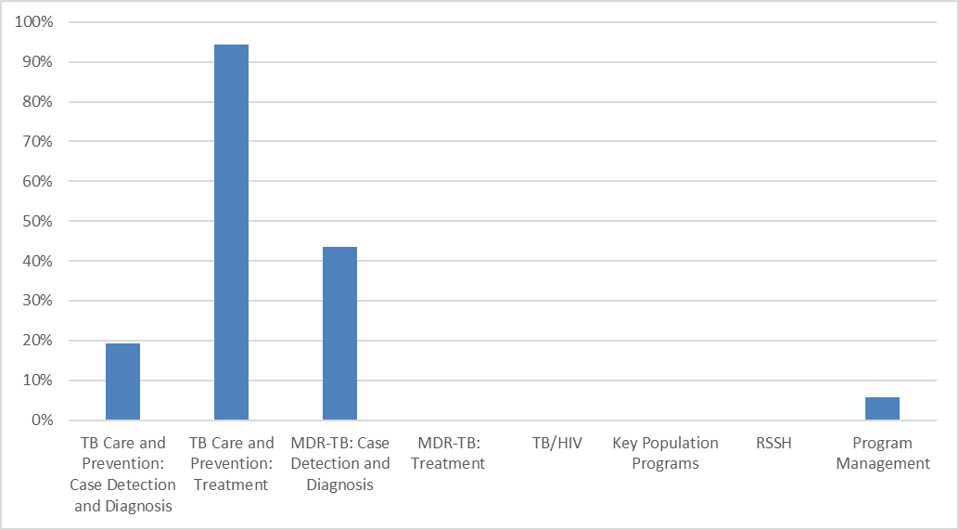

|  |
| --- |
| **4.2 Sustainability** |
| Describe below how the government will increasingly take up health program costs, and actions to improve sustainability of Global Fund financed programs. Specifically,   1. Explain the costs, availability of funds and the funding gap for major program areas. Specify in particular how the government will increasingly take up key costs of national disease plans and/or support health systems; including scaling up investments in programs for key and vulnerable population, removal of human rights and gender-related barriers and enabling environment interventions. 2. Describe actions to improve sustainability of Global Fund financed programs. Specifically, highlight key sustainability challenges of the program(s) covered by the funding request, and any current and/or planned actions to address them.   **(maximum 1 page)** |

As described above, the most significant contribution of MOH funding will be to the module “TB Care and Prevention: Treatment”, where 94% of the required funding will be covered due to the MOH commitment to fully cover the funding of first line drug requirements. Further commitments of GOB towards health program costs will be negotiated during the development of the fourth health, nutrition and population sector program, which is currently being developed in collaboration with the World Bank.The implementation of the Government’s program is scheduled to start on January 1, 2017 and should proceed as planned. The operation will just be one source of financing, planned to be available during the government’s current fiscal year, that the Government of Bangladesh will use to support program implementation. Indicative financing for this proposed operation is US$300 million from the International Development Association (IDA), as well as a potential grant from the Global Financing Facility (GFF) and potential pooled co-financing from other Development Partners. Subject to the agreement of the Development Partners, the intention is to continue to the existing practice of having a multi-donor and, as necessary, a single donor trust fund to disburse together with the World Bankfinancing in support of the government’s program.

During the development of the fourth health, nutrition and population sector program, the proposed Program for Results (PforR) financing instrument was discussed with government and Development Partners. The PforR lending instrument was inspired by such contexts as the Bangladesh Sector Wide Approach (SWAp) whereby the World Bank and other Development Partners support government program through a single platform in order to achieve the results of the full program. The evolution of the instrument puts more focus on the results and in strengthening national systems and capacities. The Program for Results instrument involves the following:

* Support to a well-defined government Program and expenditure framework;
* Disbursement of financing on the basis of achieved and verified results (Disbursement Linked Indicators);
* Implementation of the Program using government systems;
* Up-front assessment of government systems, including financial management, procurement, and environmental and social safeguards; and
* An agreed Program Action Plan for improvements and capacity development of government systems during the course of Program implementation.

It is important to note that under the Program for Results instrument allows for 25% of the financing to be advanced upon effectiveness in order to provide resources that may be used towards achieving initial results. An additional 25% of the financing may be disbursed for key results achieved prior to effectiveness. (Although, it is rare for a country to need or want to disburse this much of the operation in advance, preferring to pace the disbursement over the entire period of the program). The particular needs of the government in this regard can be discussed during the preparation.

Overall, the Program for Results instrument is designed to shift the focus of dialogue and support to government towards Program results instead of day-to-day management of transactions, at the same time that fiduciary and safeguards oversight is maintained through up-front assessment and agreement on system improvements during implementation. Clear definition, measurement, and verification of program results are the basis of this instrument.

|  |  |  |  |
| --- | --- | --- | --- |
| **SECTION 5.1: PRIORITIZED ABOVE ALLOCATION REQUEST** | | | |
| All applicants are requested to detail a prioritized above allocation request. To respond, refer to guidance in the *Instructions*and fill in the table below*.* | | | |
| Provide in the table below a prioritized above allocation request which, following the TRP review, could be funded using savings or efficiencies identified during grant-making or put on the register of UQD to be financed should additional resources become available. The above allocation request should include clear rationale and should be aligned with programming of the allocation for maximum impact. In line with the Global Fund’s Strategy to maximize impact and end the epidemics, the prioritized above allocation request should be ambitious (for example, representing at least 30-50 percent of the within allocation amount).  Applicant response in the table below. | | | |
| **[C*omponent: Catalytic Investment Funding*]** *– Copy table as needed, if your funding request includes more than one component* | | | |
|  | **Module** | **Amount requested**  [*Specify US$ or EUR*] | **Brief Rationale, including expected outcomes and impact**  (how the above allocation request builds on the allocation) |
| 1 | TB Care and Prevention: Case Detection and Diagnosis | US$9.784.593 | Further expansion of community case finding activities, introduction of the new diagnostic algorithm in additional upazilas, PPM activities targeting additional providers. Expected outcome (in combination with activities under the other modules listed in this component): case finding increased by an additional 10% (to 80% of NSP target) |
| 2 | TB Care and Prevention: Treatment | US$329.749 | Provision of drugs for additionally detected cases, further strengthening of the drug supply management system. Expected outcome (in combination with activities under the other modules listed in this component): case finding increased by an additional 10% (to 80% of NSP target) |
| 3 | Key Population Programs | US$400.734 | Additional case finding activities targeting specific risk groups (urban poor, factory workers, drivers, elderly people, pregnant women etc.). Expected outcome (in combination with activities under the other modules listed in this component): case finding increased by an additional 10% (to 80% of NSP target) |
| 4 | RSSH | US $1.484.950 | Establishment of additional laboratory facilities, implementation of electronic recording/reporting system in all upazilas. Expected outcome (in combination with activities under the other modules listed in this component): case finding increased by an additional 10% (to 80% of NSP target) |
| **TOTAL AMOUNT** | | US$12.000.027 |

|  |  |  |  |
| --- | --- | --- | --- |
| **[C*omponent: Additional Priority Interventions based on NSP*]** *– Copy table as needed, if your funding request includes more than one component* | | | |
|  | **Module** | **Amount requested**  [*Specify US$ or EUR*] | **Brief Rationale, including expected outcomes and impact**  (how the above allocation request builds on the allocation) |
| 1 | TB Care and Prevention: Case Detection and Diagnosis | US$ 41.348.864 | Full implementation of all NSP activities. Expected outcome (in combination with activities under the other modules listed in this component): achievement of 100% of NSP targets for case detection and treatment outcomes. |
| 2 | TB Care and Prevention: Treatment | US$ 327.433 | Full implementation of all NSP activities. Expected outcome (in combination with activities under the other modules listed in this component): achievement of 100% of NSP targets for case detection and treatment outcomes. |
| 3 | MDR-TB: Treatment | US$ 4.296.821 | Full implementation of all NSP activities. Expected outcome (in combination with activities under the other modules listed in this component): achievement of 100% of NSP targets for case detection and treatment outcomes. |
| 4 | TB/HIV | US$ 195.225 | Full implementation of all NSP activities. Expected outcome (in combination with activities under the other modules listed in this component): achievement of 100% of NSP targets for case detection and treatment outcomes. |
| 5 | Key Population Programs | US$ 408.949 | Full implementation of all NSP activities. Expected outcome (in combination with activities under the other modules listed in this component): achievement of 100% of NSP targets for case detection and treatment outcomes. |
| 6 | RSSH | US$ 1.160.595 | Full implementation of all NSP activities. Expected outcome (in combination with activities under the other modules listed in this component): achievement of 100% of NSP targets for case detection and treatment outcomes. |
| 7 | Program Management | US$ 1.381.455 | Full implementation of all NSP activities. Expected outcome (in combination with activities under the other modules listed in this component): achievement of 100% of NSP targets for case detection and treatment outcomes. |
| **TOTAL AMOUNT** | | US$49.119.341 |

1. R. Houben et al, TIME Impact - a new user-friendly tuberculosis (TB) model to inform TB policy decisions, BMC Med. 2016 Mar 24;14:56. doi: 10.1186/s12916-016-0608-4.
2. Systematic screening for active tuberculosis: principles and recommendations; WHO/HTM/TB/2013.04
3. Chest radiography in tuberculosis detection – summary of current WHO recommendations and guidance on programmatic approaches.WHO/HTM/TB/2016.20
4. Excel modeltoassessapproximateannualbudgetsfor different diagnosticalgorithms, NTP Bangladesh 2016
5. In sites with X-pert facilities, all suspects get X-ray, then X-ray positives get X-pert. In other sites (that lack of X-ray), all presumptive will get X-pert directly. Presumptive DR TB (9 criteria) referred from other sites will get directly X-pert
6. National Strategic Plan for Public-Private Mix (2016-2020), National TB Control Programme,

   Directorate General of Health Services
7. WHO treatment guidelines for drug-resistant tuberculosis, 2016 update. October 2016 revision.WHO/HTM/TB/2016.04
8. Refer to the [Global Fund 2017 Eligibility List](http://www.theglobalfund.org/en/fundingmodel/process/eligibility/)for income level. LMI and UMI countries have specific requirements in terms of the focus of applications as set forth in the Global Fund [Sustainability, Transition and Co-Financing Policy](http://www.theglobalfund.org/en/fundingmodel/process/cofinancing/).
9. Refer to the [Sustainability, Transition and Co-Financing Policy](http://www.theglobalfund.org/en/fundingmodel/process/cofinancing/).